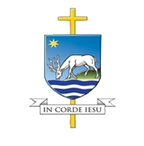 | CATHOLIC DIOCESE OF PORTSMOUTH  CURRENT EDUCATIONAL VACANCIES  Week ending 5 September 2025 | 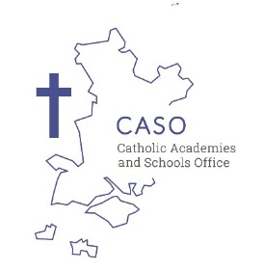

For further information on any of the vacancies listed either click on the relevant link or visit the recruitment section of the CASO website (http://www.casoportsmouth.org.uk/current-vacancies/)
Leadership & Teaching Vacancies
Details of Vacancy | Closing Date
Deputy Headteacher required for January 2026 at St Patrick’s Catholic Primary School, Farnborough | 05.09.25
GCSE English Re-sit Tutor required as soon as possible – fixed term contract to 30.06.26 required for St Peter’s Catholic School, Bournemouth | 10.09.25
Teacher of Drama (Part-time) required from January 2026 for Beaulieu Convent School, Jersey | 11.09.25
Teacher of English, with potential for additional responsibility required from January 2026 for Beaulieu Convent School, Jersey | 11.09.25

Teaching & Learning Support Vacancies
Details of Vacancy | Closing Date
Teaching Assistant (Secondary) – 30 hours per week – term time only – required as soon as possible for St Peter’s Catholic School, Bournemouth | 04.09.25

School Support Vacancies
Details of Vacancy | Closing Date
Assistant Chaplain – required as soon as possible for St Peter’s Catholic School, Bournemouth | 04.09.25

To place an advert on the vacancies section of the CASO website (http://www.casoportsmouth.org.uk/current-vacancies/) please complete the Word template found on the page and return to schools@portsmouthdiocese.org.uk

This bulletin is circulated to all diocesan schools and those subscribed to our mailing list each Thursday during term time. Deadline for receipt of adverts is 4.00 pm on Wednesday.

If you would like to subscribe to the weekly email alert service for newly placed adverts, please email schools@portsmouthdiocese.org.uk

